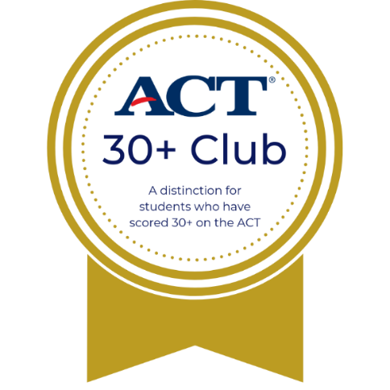
<School Name> <Year>

30+ Club
In honor of your outstanding performance and dedication towards achieving a 30 or higher on the ACT, this certificate is awarded to
<Student Name>
<Counselor name>
School Counselor

<Principal name>
Principal

