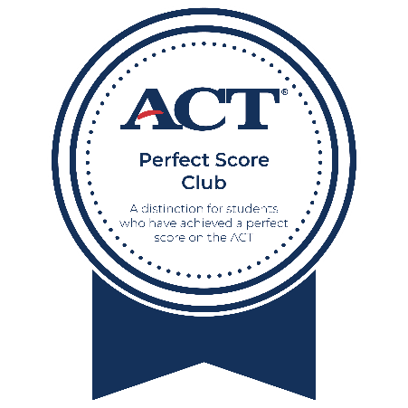
<School Name> <Year>


Perfect Score Club
In honor of your outstanding performance and dedication towards achieving a Perfect Score on the ACT, this certificate is awarded to
<Student Name>
<Counselor name>
School Counselor

<Principal name>
Principal

