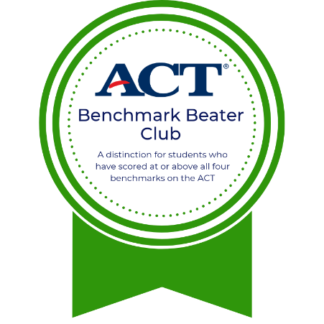
<School Name> <Year>

Benchmark Beater Club
In honor of your outstanding performance and dedication towards meeting or exceeding all benchmarks on the ACT, this certificate is awarded to
<Student Name>
<Counselor name>
School Counselor

<Principal name>
Principal

