The Enhanced ACT Explained

ACT has made some exciting changes to help students maximize their scores and feel more confident on test day. The ACT is now shorter, allows more time per question, and gives students more options for how they test. These updates are designed to help students shine while maintaining the high standards colleges expect.
Here’s everything you need to know to support your students this year.

What’s Changing?
The ACT has introduced several enhancements designed to improve the student testing experience:
- Shorter Test
  - The total test time has been reduced by 75 minutes, with 44 fewer questions overall.
- More Time Per Question
  - Students will have more time to think through each question, helping reduce pressure and improve focus.
- Optional Science Section
  - Science is now optional. For National (weekend) testing, students can choose whether or not to include the science section, based on their future goals and strengths. State and district customers can choose whether to include the ACT science and writing sections for their students.
- Choice of Test Format
  - Students now have the option to take the test online or on paper, depending on what they’re most comfortable with.
- Fewer Answer Choices in Math
  - The math section now includes four answer choices instead of five, making it easier to decide and improving the odds of selecting the correct response.
- Updated Composite Score
  - The new Composite score includes English, math, and reading scores only (EMR). If a student chooses to take the science section, they’ll also receive a separate science and STEM score—giving them a more complete view of their strengths.

What’s Not Changing
These updates make the ACT more flexible, but the core structure and standards remain the same:
- The ACT scale is still 1–36
  - There are no changes to ACT Benchmarks or state-specific achievement standards.
- English, math, and reading are still required
  - Science and writing are optional.
- Legacy Composite Scores
  - Composite scores from tests taken before the rollout of the new Composite score will not change.
- College Acceptance
  - Colleges will continue to use the ACT to evaluate academic readiness and determine course placement
The good news is that we’ve heard from both students and educators that using legacy ACT questions is still a helpful way to practice for the enhanced ACT. That’s because, even with the updates, the types of knowledge and skills measured by the test haven’t significantly changed. So, whether students are working through full-length practice tests, shorter practice passages, or quick classroom bell ringers, the resources you’ve been using continue to be great tools for ACT prep.
New! Released September 30th — Two full-length online practice tests have been added on the ACT Online Sample Questions page. These tests incorporate the enhancements made to the ACT and are freely available for students and educators.

Why These Changes Were Made
Students asked for more flexibility, and ACT listened. The result is a test experience that feels more manageable, while still delivering the trusted data schools and colleges rely on.
Here’s what we heard from students:
“The test is too long. I need more time!”
The enhanced ACT is shorter and allows more time per question. This helps students feel less rushed and more confident as they work through each section.
“The science section scares me.”
Now, students can choose whether to take the science science. Those who want to highlight STEM strengths can still opt in and receive detailed score reporting.
“I don’t want to test on a computer. I still want paper!”
Students can now select the format that works best for them — online or paper. This flexibility supports comfort, confidence, and performance.

When Will These Changes Happen?
The enhanced ACT is already available for National (weekend) test takers. Students registering for the 2025–2026 ACT test dates can now choose the format of their test (online or on paper) and whether to include the science section. State and district and international testing will begin using the enhanced ACT in spring 2026.

Superscoring Updates
The core change in scoring is the shift to the EMR (English, math, and reading) model for both the ACT Composite score and the ACT Superscore. This change took effect for all score reporting starting in September 2025. The General Rule is that beginning September 2025, the ACT Composite score (single test date) and the ACT Superscore (multiple test dates) will be calculated using only the scores from the English, math, and reading sections.
If a student’s first ACT test is taken in September 2025 or later, their Composite score and Superscore will never include a science score in the calculation.
Score Blending: If a student tested before September 2025 (under the legacy four-section ACT that included science as a core test) and then tests again after September 2025 (under the enhanced three-section ACT test that only includes English, math, and reading as the core test). When blending scores from the legacy ACT and the enhanced ACT, a student’s Superscore might drop because the previous calculation included the science section score that is now excluded.
For this small group of students, a “Highest Superscore” report option will be made available on their MyACT account. This option allows them to view their best-ever Superscore calculated under the legacy, four-section calculation.
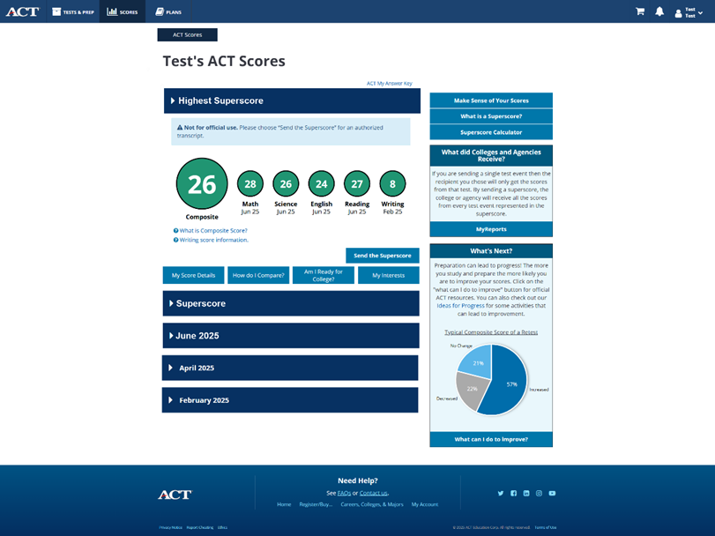

Final Thoughts
ACT’s goal is simple: to help students succeed in a way that works for them. These enhancements give students more control, alleviate stress, and provide a testing experience that better aligns with student needs and goals.
Need more info? Visit the ACT Test Enhancements webpage for updates, visuals, and a complete list of FAQs to share with families and students.

